**Lane Detection steps (No data set needed for this algorithm, as it is pretrained)**

1. Make sure you have a GPU GeForce GTX 1060 or later
2. Download Jupyter Notebook (Latest Version)
3. Pytorch 1.7.1
4. Download the folder “Line_and-crack_Detection--main”
5. Launch Jupyter and open python file “video_main”
6. Select run and run all
7. If you have another video file that you wish to perform line detection on, you simply need to save the video to the “Line_and-crack_Detection—main” folder and change the name of the video file from “project_video.mp4” in the “video_main” file to the new video name that you copied in the folder. Check figure bellow.  
     
   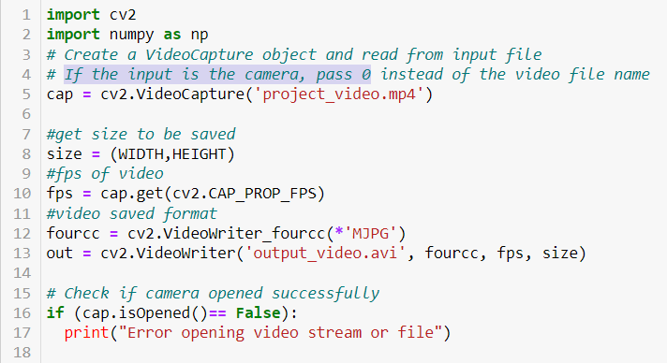
8. The output video with the shoulder lanes marked will launch automatically, and will be saved as “output_video”